B.Voc APPAREL AND FASHION DESIGN JAMAL MOHAMED COLLEGE, TRICHY-20
ASSOCIATION ACTIVITIES OF THE DEPARTMENT
June 2020– March2021

Inauguration of the Association Activity | 22.09.2020
Chief Guests -A.K.B. Nawas Babu
Managing Director S.A.Knitwears Pvt Ltd, Madurai

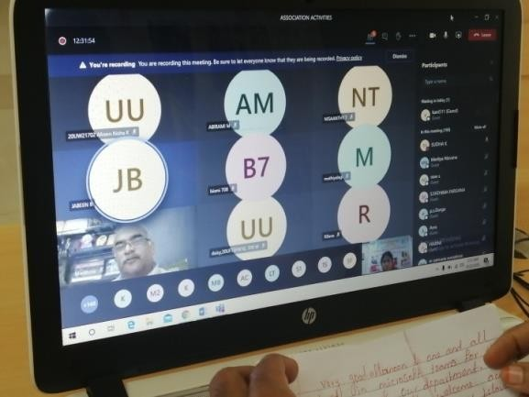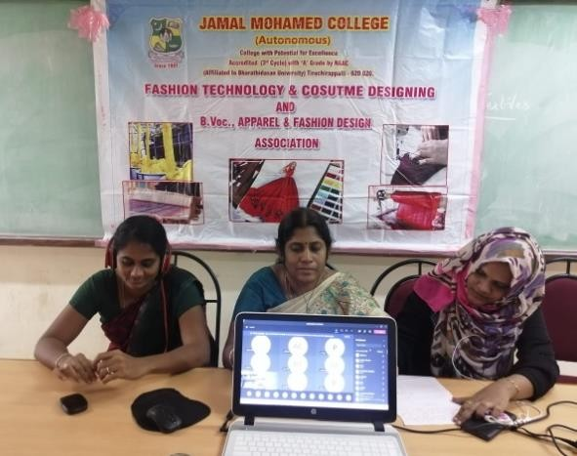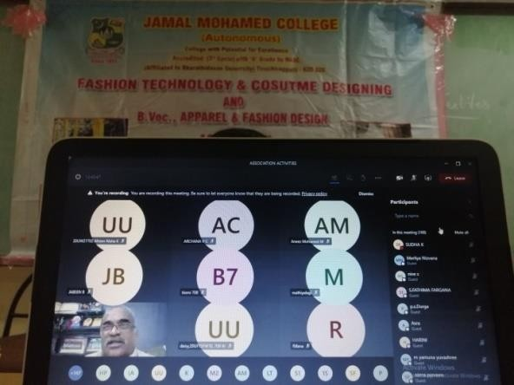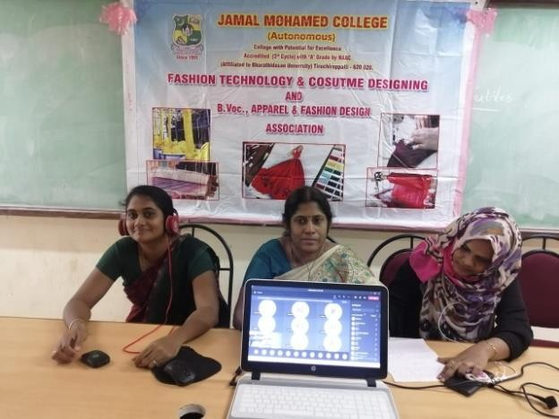

Inauguration of Association Activity programmed was held on22.09.2020 and inaugurated
Mr. A.K.B Nawas Babu, Managing Director of S.A.Knitwears Pvt Ltd Madurai through online platform Microsoft teams.The inauguration started with Qirat and welcome Address by our Coordinator.The Chiefguest gave a wonderful lecture on the Scope of Fashion Designing . The 70 B.Voc students attended through the online platform. The speech gave an inspiration to the students entering into their career path.

COTTON WEEK | 13-10-2020 to 16-10-2020
Chief Guests - Mr.Gorpasave ravi
Denim Fashion Designer
Levis India Pvt Ltd Banglore India

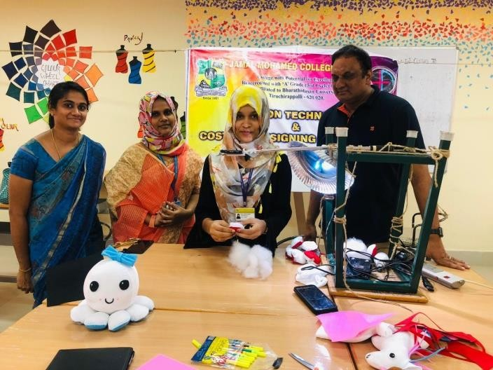
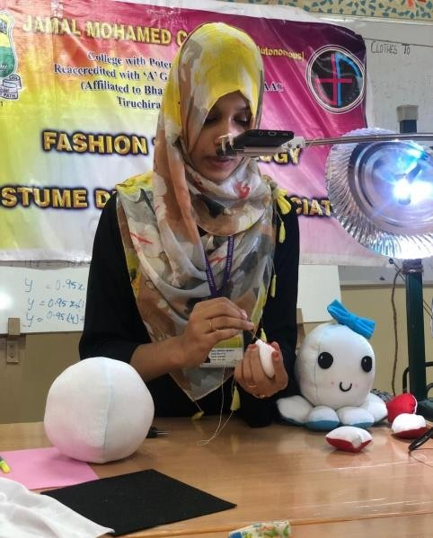

13-10-2020- Toy making Workshop

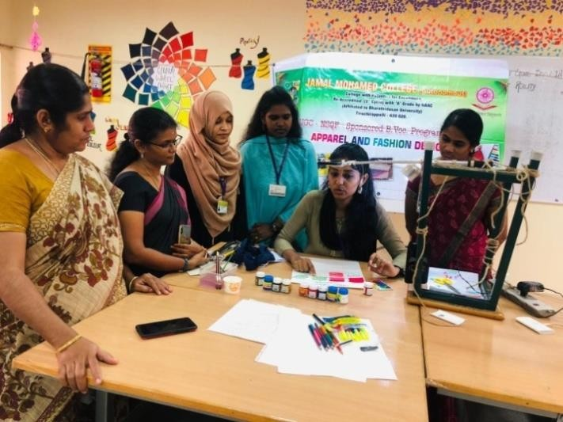
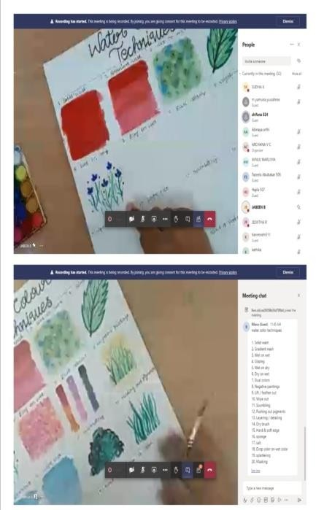

14-10-2020-painting Workshop

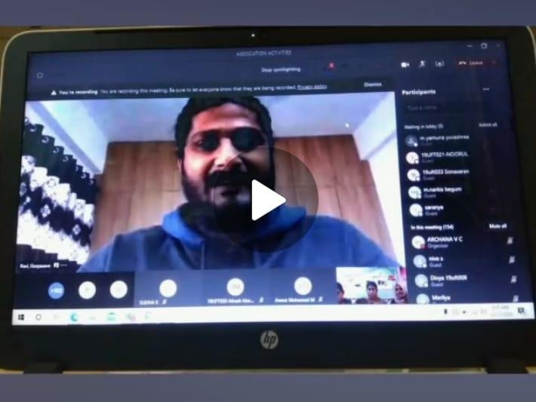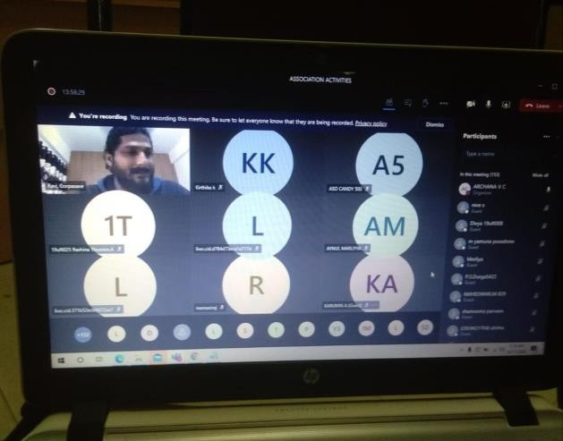

The Cotton week Celebration was conducted with related to the world Cotton day .The 70 B.voc students participated in the workshops and in the special lecture .The week Started with workshop on toy making on 13/10/2020 ,the Painting workshop was organised on 14/10/2020 and a competition was organised for the freshers ,A special lecture was Conducted on the Final day by Mr.Gorpasave Ravi.Denim Fashion Designer ,Levis India from banglore .The lecture was about the Sustainable fashion where we can create a green Environment without the waste of Natural Resources .He had an interaction with our students .This was the Felicitation which ended up by the awareness of Cotton created by our students through online

Mural Art Workshop | 07-11-2020
Chief guest Ms.Vasumathi
NIFT-TEA College of Knitwear Fashion,Tirupur

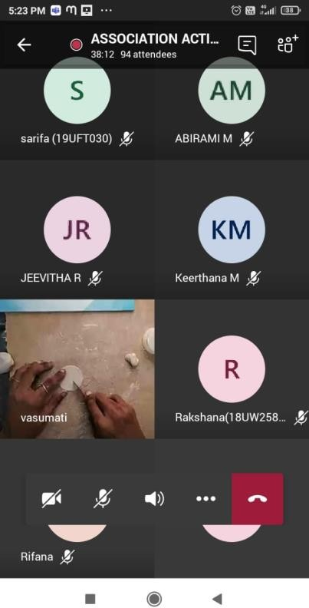
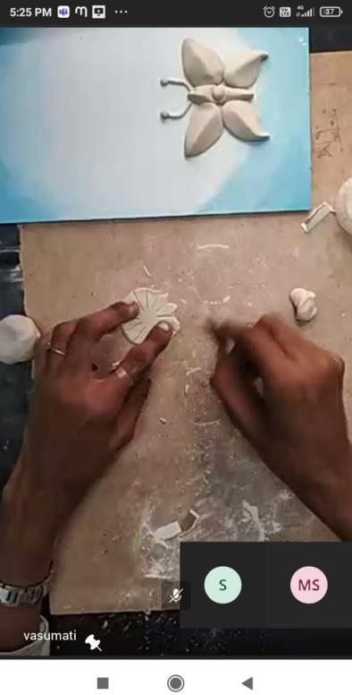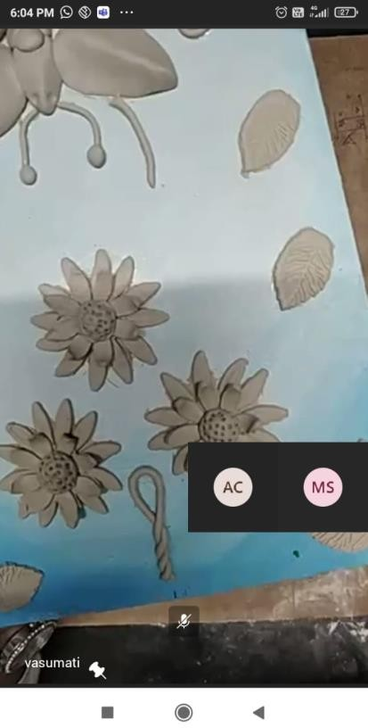

The Mural Art, One of the traditional Style of Craft work organized for the 3d designing, to inculcate the value of crafts. The Workshop was conducted by Ms Vasumathi, Nift Tea College of Knitwear Fashion. The II B.voc and III B.Voc Students participated and created their own style of Mural arts through the instruction provided by the lecturer. The students took immense pleasure in creating the wall hangings by using their creative molds .They also participated in the fevicryl’s work book .They forecasted their work along with fevicryl team .

International Seminar on  Modern Perspectives in Sustainable fashion and Digital Marketing | 2-2-2021 ; 3-2-2021
Chief guest 1.Ameer Kuwait, 2.Mr.Karthik Designer from Sting Fashion ,
3.Dr .Ammen Rubeena CMO Trichy , 4.Ms Gowsi,Model and Fashion Blogger from Germany 5.Ms.Antara Bhattacharya from Dreamzone

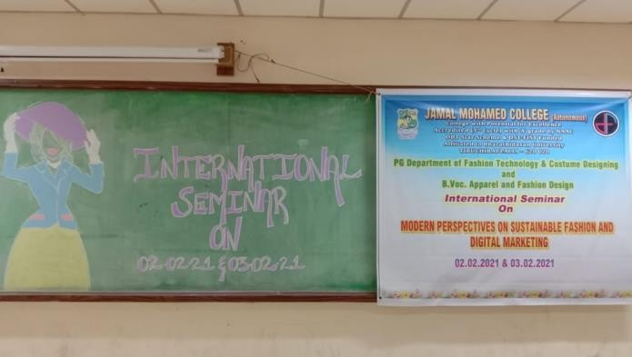
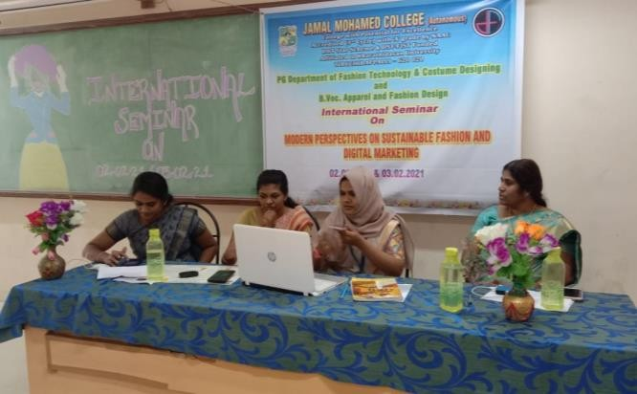
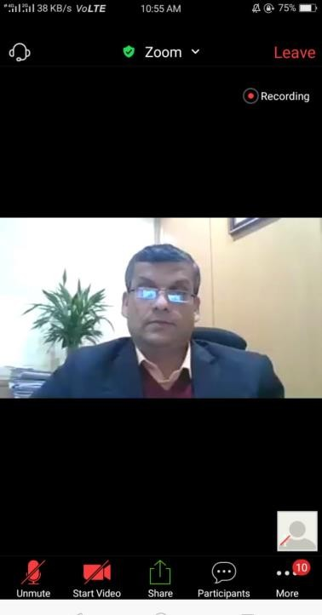
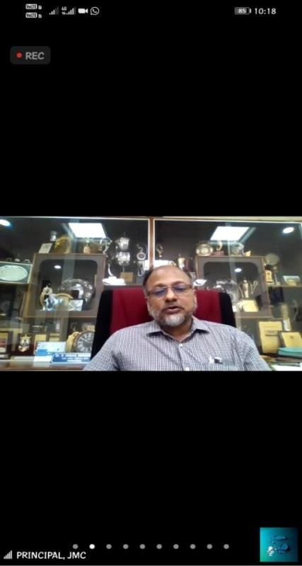
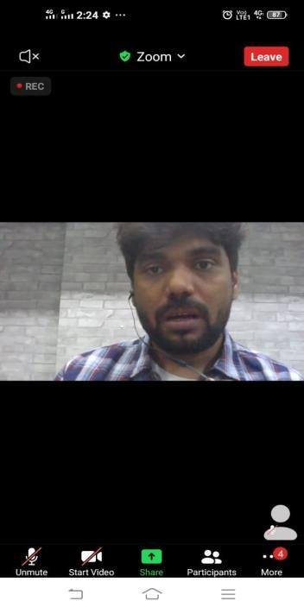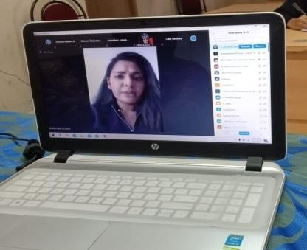

Our principal Presides over the Function. Dr.Ameer inaugurates and lectures on the Digital Marketing Followed by Mr.Karthick about the Sustainable and Design Catogories in the fashion Sector. Ms Gowsi elaborates about the blogs and modelling

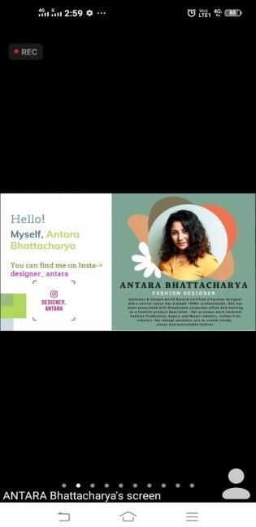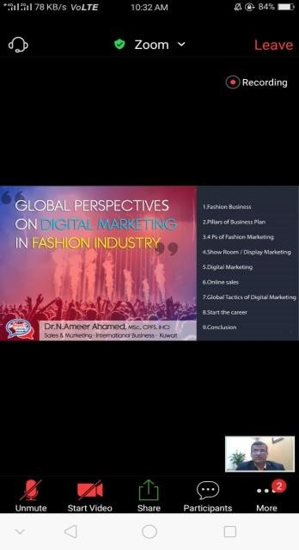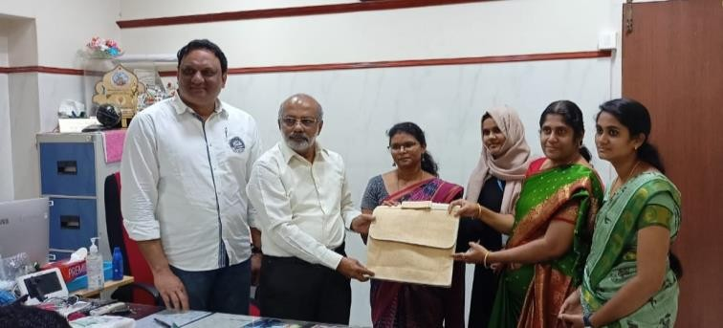

Ms. Antara Bhattacharya Speaks on the Sustainable Fashion and its Scope. Dr. Ameen Rubeena Explains the need of textiles in medical field
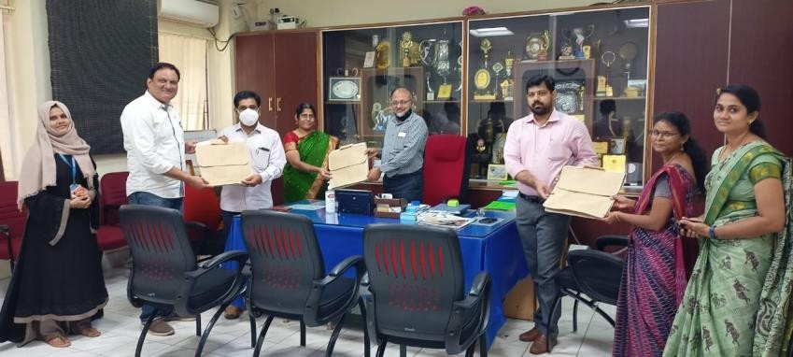

The International Seminar was organized on 2/2/2021 and 3/2/2021 on Modern Perspectives on Sustainable fashion and Digital Marketing. Many Colleges from India and internationally were invited. The speakers for the Seminar were Dr.Ameer from Kuwait,Mr.Karthik ,Designer from Sting Fashion ,Dr .Ammen Rubeena CMO Trichy , Ms Gowsi,Modl and Fashion Blogger from Germany and Ms.Antara Bhattacharya
,from Dreamzone .Many Participants Students and Professors presented articles .The Presidential Address was given by our Principal .Nearly 300 Participants attended the seminar. The participants were from Chennai, Salem, Nammakal Erode, Haryana
,Gujrath etc.

Association valedictory | 12-3-2021
Chief guest Dr. Padmanaban
Research Advisor Former Scientist ,NBRC
Jamal Mohamed College ,Trichy

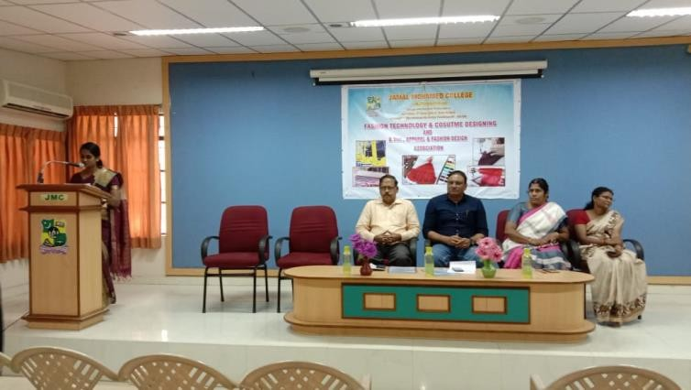
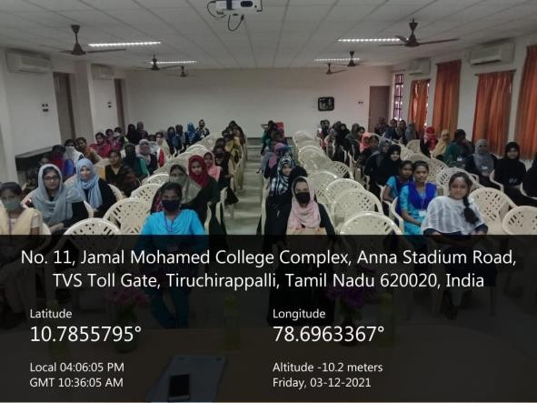

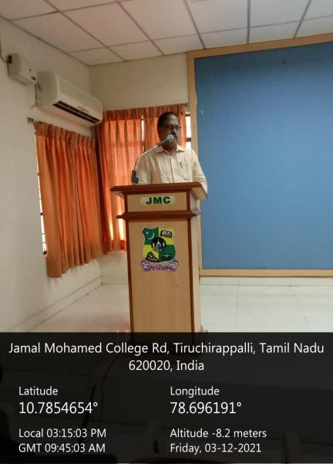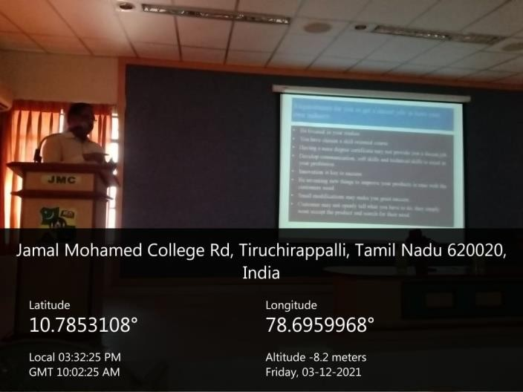

The Validictory of the Association was held on 12-3-2021.Dr.Padmanaban Research Advisorattended and gave a sppech on the scope of Fashion designing .He encouraged students to take up new Challenges based on this Skill Oriented Course. The Students of B.Voc Apparel and fashion Design participated and the knowledge on todays Eco friendliness,the sustainable fashion ,The traditional arts and the handcrafted products were focoused .The Advisor advised the students on how to advertise the products and earn for the future

